Network Fundamentals

HTTP in Detail

**Task 1:**

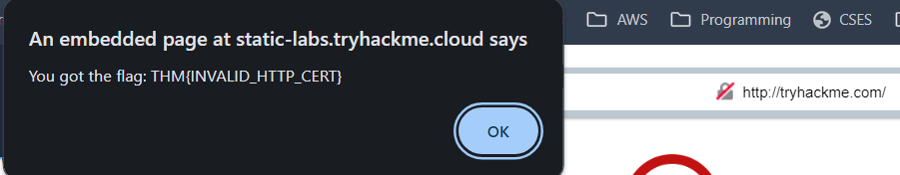

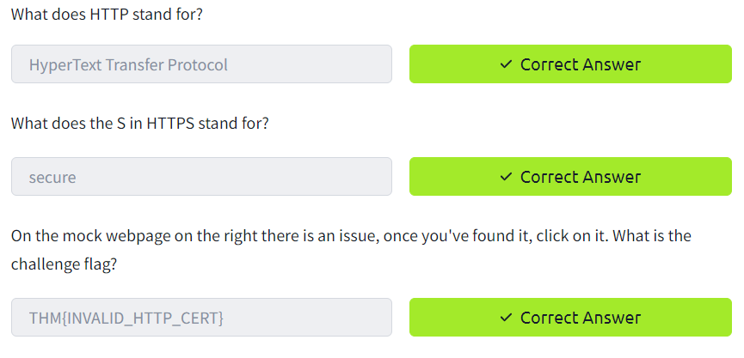

**Task 2:**

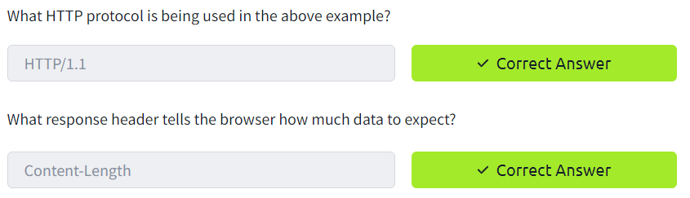

**Task 3:**

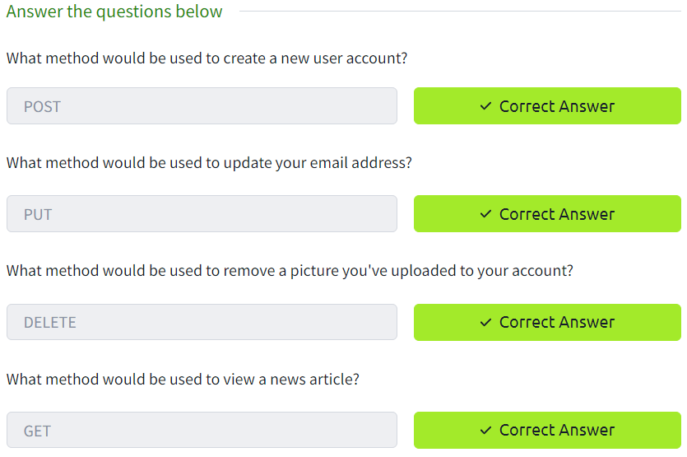

**Task 4:**

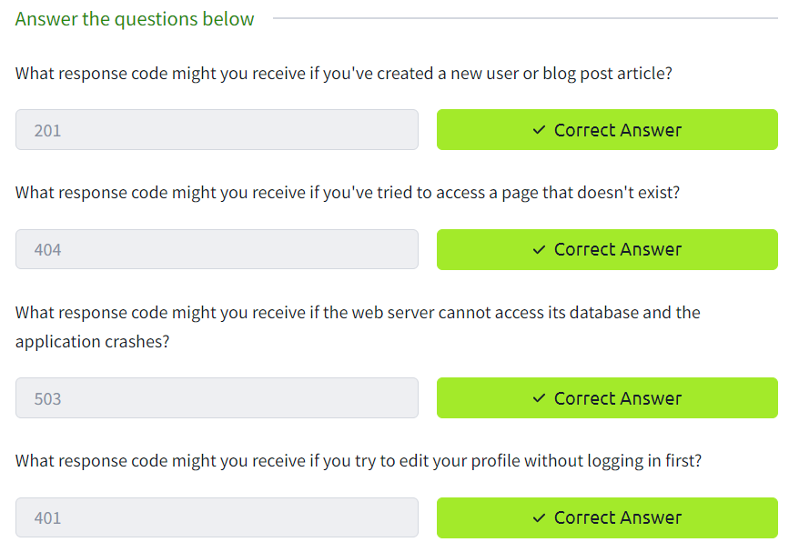

**Task 5:**

Headers are additional bits of data you can send to the web server when making requests.

**User-Agent:** This is your browser software and version number

**Accept-Encoding:** Tells the web server what types of compression methods the browser supports so the data can be made smaller for transmitting over the internet.

**Cookie:** Data sent to the server to help remember your information

**Set-Cookie:** Information to store which gets sent back to the web server on each request (see cookies task for more information).

**Cache-Control:** How long to store the content of the response in the browser's cache before it requests it again.

**Content-Type:** This tells the client what type of data is being returned, i.e., HTML, CSS, JavaScript, Images, PDF, Video, etc.

**Content-Encoding:**What method has been used to compress the data to make it smaller when sending it over the internet.

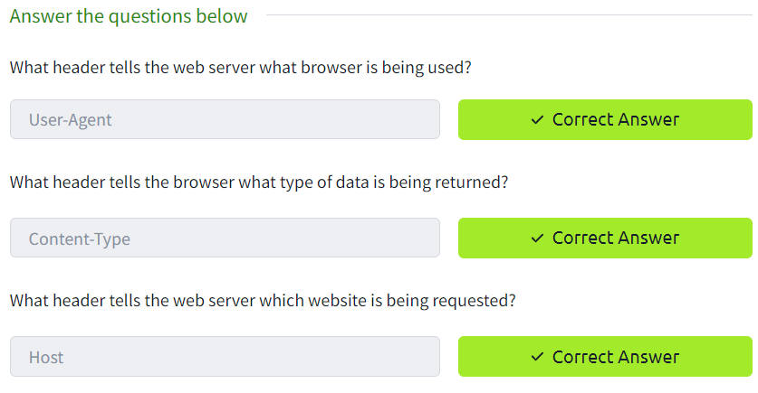

**Task 6:**

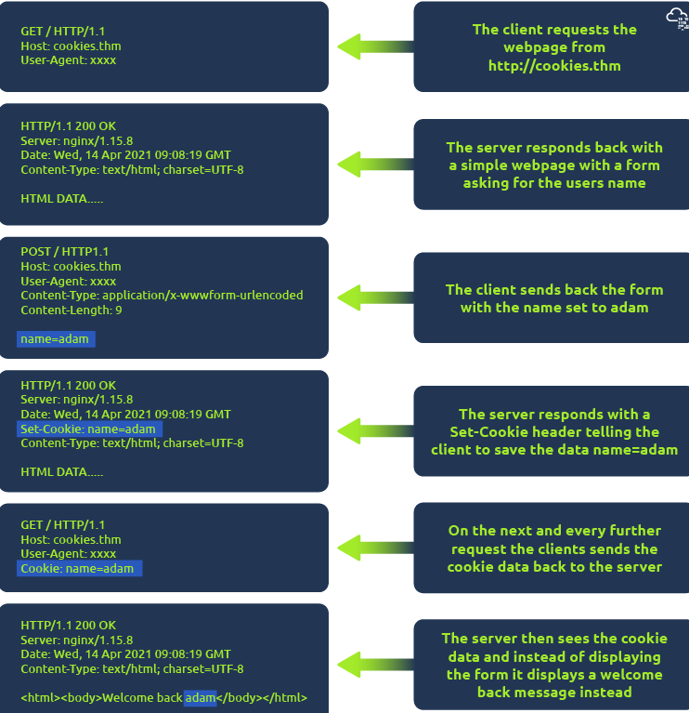

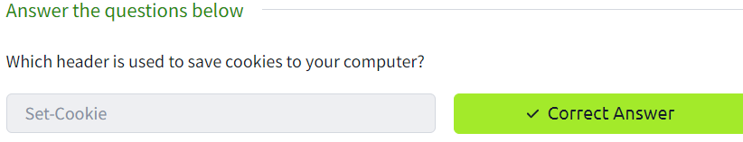

**Task 7:**

